The LabVIEW program of high-k scattering system on NSTX-U

Xinhang Xu,8/17/2024

The program comprises both monitoring and control modules. The control module is responsible for managing the launch and receiver optical setup as well as adjusting the formic acid laser. The monitoring module oversees various parameters, including the power supply, laser output, ambient temperature and humidity, cooling liquid flow velocity and temperature, and the formic acid gas pressure within the laser tube.

Contents

I. The Control Module 1

1.1 FIR Monitoring and Control 1

1.2 Receiver and Launch Optical Control 2

1.2.1 Receiver Optical Control 2

II. The Monitor Module 5

2.1 CO2 Power Supply and Laser Monitor 5

2.2 Cooling Water &Formic acid gas monitor 6

2.3 Atmospheric Environment 8

# The Control Module

## FIR Monitoring and Control

In the Control Module, as illustrated in Figure 1, the system includes a laser power adjustment interface along with control panels for both the receiver and launch optical setups.

Figure High-k Scattering System Control panel

The laser power adjustment is facilitated by a Thorlabs stepper motor, which controls the cavity length through a belt-driven micrometer with a resolution of 0.5 µm, as depicted in Figure 2. The cavity length is determined by the position of the coupler, which could be adjusted remotely to optimize laser power output. The motor is controlled via the **FIRLaserAdjustment** interface, as shown in Figure 3. During the motor adjustment, the FIR laser power monitor provides real-time feedback on the laser output, enabling precise identification of the optimal coupler position. The control system allows for movement within a range of 0 mm to 12 mm.

Figure FIR laser output coupler

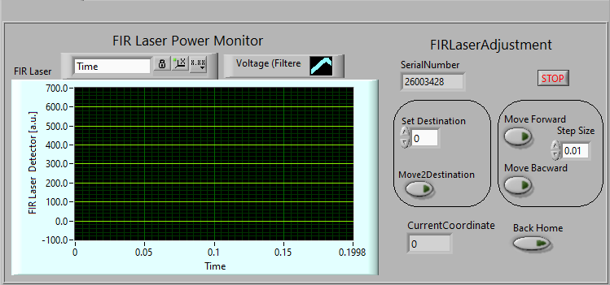

Figure FIR Power monitor and motor adjustment

## Receiver and Launch Optical Control

### Receiver Optical Control

The Receiver and Launch optical control panel is illustrated in Figure 3. For the Receiver optics, four axes are available for control: The Z axis, Radial axis, Tilt axis, and Toroidal axis, as depicted in Figure 4. The four-axis adjustment determines the focus position of the receiver optics. The relationship between the focus position and the four optical axes has been previously discussed in the presentation(https://ucdavis.box.com/s/p2mc06lw7efr0v2cxymbmrzxwwakfk3r).

Figure Receiver Optical arrangement

The control panel features options for Computer Mode, Manual Mode, and Status Check.

In Computer Mode, users can select the antenna input, set the receiver antenna position, and calculate the focus position, referred to as the Interaction Region (IR). Additionally, users can select the IR input, set the IR, and calculate the corresponding antenna position. If the positions are correctly arranged and the results are satisfactory, the "**AutomoveAntenna**" button can be pressed to automatically move all motors to their designated positions. Similarly, the "**AutomoveLaunch**" button adjusts the launch angle based on the IR. It is important to illustrate the installation procedure for the launch mirror, as the available angle range for installation is limited to -6 to 6 degrees. Improper installation will prevent correct adjustment of the launch angle.

In Manual Mode, users can independently select and adjust the position of each stepper motor. The system allows for setting a specific destination and moving the motor to that location, or alternatively, jogging around the destination to identify the optimal position.

In Status Check Mode, users can monitor the position of each stepper motor and verify whether the actual positions correspond with the calculated results obtained from Computation Mode.

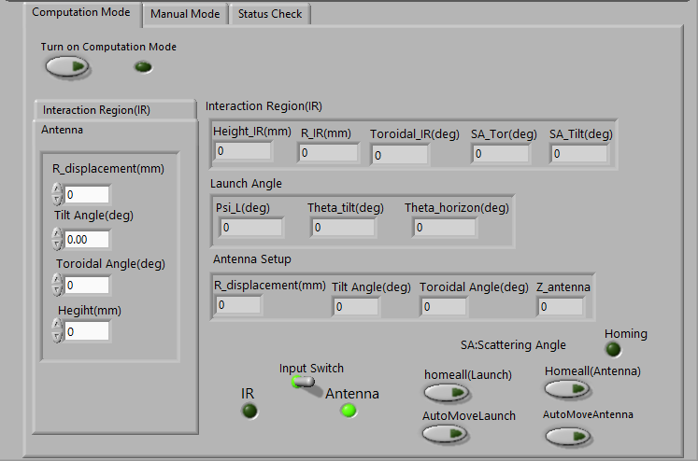

Figure Computation Mode panel

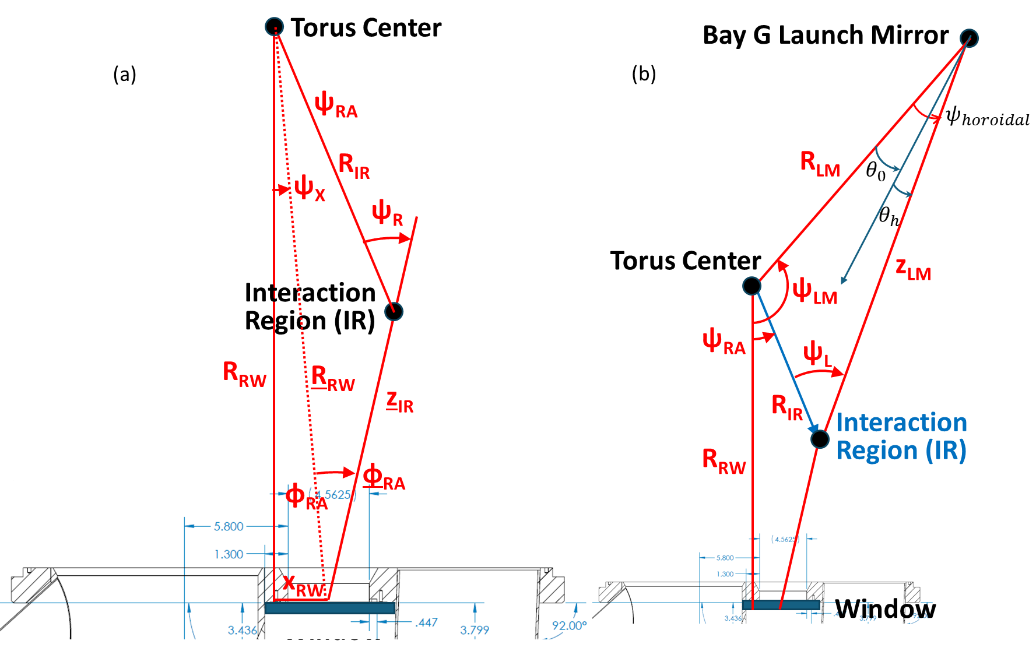

Figure Receive optical(a) and launch optical(b) sketch

*Table 1 Output parameters in Computation mode*

|  |  |  |
| --- | --- | --- |
| Parameters in Pannel | Note in sketch | explanation |
| Interaction Region (IR) | | |
| Height_IR(mm) | none | The relative height of IR above the midplane of NSTX-U |
| R_IR(mm) | $$R_{IR}$$ | Major radius of interaction region |
| Toroidal_IR (mm) |  | Toroidal angle of interaction region (refer to plane of vacuum window) |
| SA_Tor(deg) |  | Toroidal angle between receiver beam and Radius vector |
| SA_Tilt(deg) | none | The tilt angle between the receiver direction and the midplane |
| Launch Angle | | |
| Psi_L(deg) | ψL | Toroidal angle between launch beam and Radius vector |
| Theta_tilt | none | Tilt angle between launch beam and midplane |
| Theta_horizon | $$θ_{h}$$ | Horizontal angle between radius vector and launch beam in the midplane |
| Input Switch/Antenna | | |
| R_displacement(mm) | Figure4:R motor | R antenna Motor adjustment |
| Tilt Angle(deg) | Figure4:tilt motor | Tilt antenna Motor adjustment |
| Toroidal Angle(deg) | Figure4: Toroidal motor | Toroidal antenna motor adjustment |
| Height(mm) | Figure4:Z motor | Z antenna motor adjustment |
| Input Switch/IR | | |
| Height_IR(mm) | none | The relative height of IR above the midplane of NSTX-U |
| R_IR(mm) | $$R_{IR}$$ | Major radius of interaction region |
| Toroidal_IR (mm) |  | Toroidal angle of interaction region (refer to plane of vacuum window) |
| SA_Tor(deg) |  | Toroidal angle between receiver beam and Radius vector |
| SA_Tilt(deg) | none | The tilt angle between the receiver direction and the midplane |

# The Monitor Module

## CO2 Power Supply and Laser Monitor

When the CO2 laser is operating normally, the voltage on the power supply display should be 16 kV, and the current should be 40 mA. We have two monitor channels corresponding to two power supplies, as shown in Figure 7(b); Now day, only the current monitor is checked in the LabVIEW program, as shown in Figure 8.CO2 power monitor need to be done for a while.

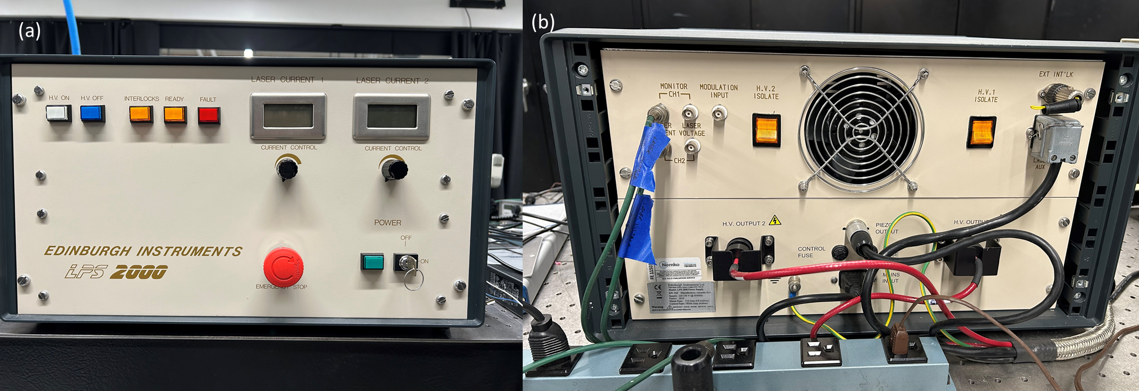

Figure 7 (a)The Front panel of CO2 Laser Power supply(b)The rear panel of CO2 Laser Power supply

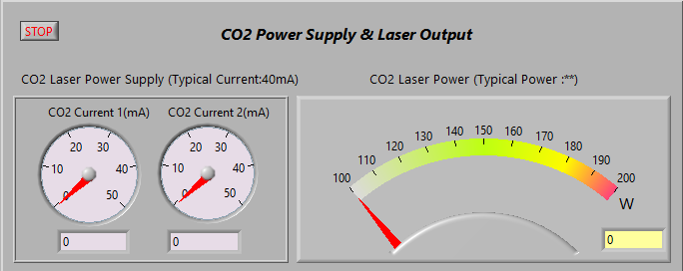

Figure 8 CO2 power supply current monitor and CO2 power monitor

## Cooling Water &Formic acid gas monitor

Figure 9 shows the temperature and flow sensor for the cooling water. The model number is 0V7008STA32. The input DC voltage is 24V, and the relationship between flow velocity and voltage output is (https://www.proteusind.com/product/v7000-series-vortex-flow-meters)

$$Q\left(LPM\right)=3.2×V_{out}$$

The relationship between temperature (OC)and voltage is

$$T=\left(V_{out}×15\right)-25$$

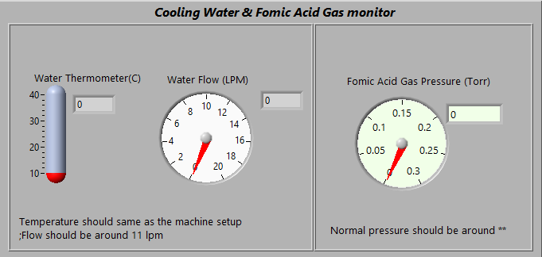

Figure 9 Cooling water monitor and Formic Acid gas pressure monitor

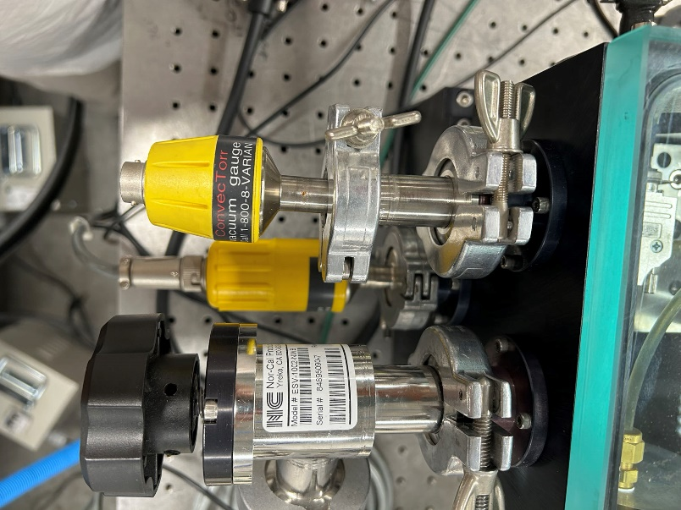

Figure 10 Formic acid gas pressure sensor

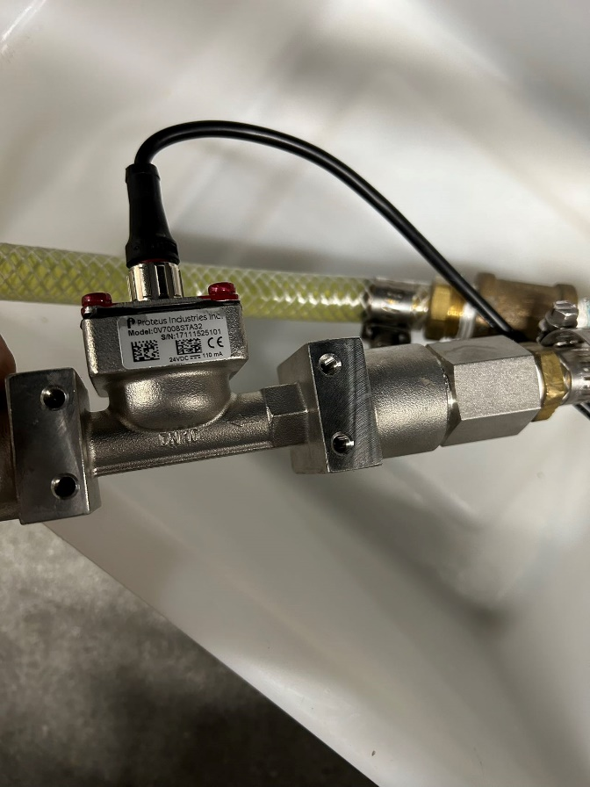

Figure 11 Cooling water flow and temperature sensor

Figure 10 shows the formic acid pressure sensor ,the TC ConvecTorr Algorithm: Converting recorder output voltage to pressure To calculate the pressure from the voltage output Example recorder output = 3.28 volts DC To get the exponent, take the integer part of voltage output which is 3 and subtract 4: 3 – 4 = –1 (E-1) Now to find the mantissa, take the fractional portion and add .1 to it and divide by .11: (.28 + .1)/.11 = 3.45 therefore: 3.28 VDC = 3.45E-1 Torr(https://www.idealvac.com/files/ManualsII/VariansentorrBA.pdf,page23)

## Atmospheric Environment

The atmospheric environment is monitored by a sensor connected to the computer to check the ambient temperature and humidity of the system, as shown in Figure 12.

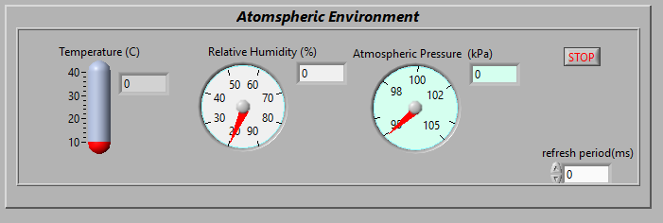

Figure 12 Humidity, Temperature and Atmospheric Pressure Monitor